January - February 2023
Metcalfe County Family and Consumer Sciences Extension and Homemakers Newsletter
Serving ALL Kentuckians
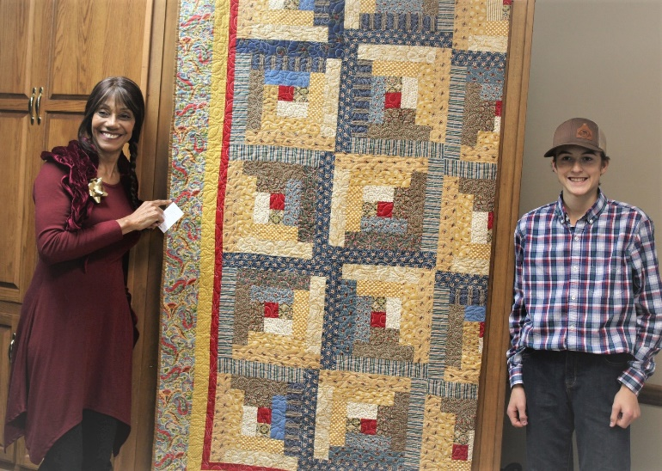
12-8-2022: Colette VonTassen, 2022 Quilt fundraiser winner accepting the quilt, on behalf of her daughter, with Layton who drew the winning ticket.
A BIG Thank you to Metcalfe County Piecemakers Quilt Guild, for making and donating this beautiful quilt, and to ALL Homemaker members who assisted with the 2022 Homemaker Quilt fundraiser. $ 579.00 was raised and donated to the UK – KY Extension Homemakers Ovarian Cancer Screening and Research Project.
The winning ticket was drawn by County President, Peggie McCoy’s grandson Layton, at the annual Homemakers Christmas meeting on Thursday December 8, 2023.
There is currently a vacancy on the Metcalfe County Homemakers council for the chairperson position for the 4 – H and Youth Development program area.

If you are able to attend most of the County Council meetings at the Extension office in Edmonton, from 1:00 – 2:00 p.m. on the following dates: April 4, 2023; July 11, 2023; September 5, 2023; and November 7, 2023, we would love to have your input on the County Homemakers Advisory council.
Please contact Lynn Blankenship, at 270-670-3220, if you can assist. This is the perfect opportunity for members who are retired teachers to become involved at the County level, if you are able to serve in this way.
This Photo by Unknown Author is licensed under CC BY-SA-NC
This Photo by Unknown Author is licensed under CC BY-NC-ND
Annual non-discrimination statement:
The University of Kentucky Cooperative Extension Service, is committed to equal opportunity and nondiscrimination in all programs, events and services, regardless of economic or social status and does not discriminate on the basis of race, color, ethnic origin, national origin, creed, religion, political belief, sex, sexual orientation, gender identity, gender expression, pregnancy, marital status, genetic information, age, veteran status, or physical or mental disability. The University of Kentucky provides reasonable accommodation upon request.
Metcalfe County Homemakers need two members to attend the annual State meeting May 9 – 11, 2023, and serve as voting delegates. These members can ride with Lynn Blankenship if they want to.
Please let Lynn know by March 15th, if you want/are able to attend. Call Lynn at 270-670-3220.
The County Council reimburses the member for the early bird registration fee ($ 140.00) and for 1 hotel room with two queen beds for the members attending to share. Please let Lynn know by March 15th if you can attend.
2023 KEHA State Meeting -- May 9-11, 2023 at the Crowne Plaza, Louisville, KY. https://keha.ca.uky.edu/content/state-meetinginformation
Family mealtime: a tasty base for healthy youth development
Between work, running errands and after-school activities, meals on the go have become a staple for many American families. You may not realize taking those few extra moments to sit down for a meal with your family fills more than just your stomach.
Sitting down for a family meal is one of the easiest proven methods to enrich your young person’s life. Psychologically, regular family mealtimes help youth do better in school on tests, homework and improve general intellectual development. Social benefits include better social adjustment, especially for teenagers, and stronger family bonds.
Family mealtimes also have nutritional benefits. Having regular balanced meals featuring nutritious foods helps your young person develop healthy eating habits and establish a healthy relationship with food.
Convenience is a significant factor when choosing what to eat, leaving many families choosing the instant gratification of fast food. You may cringe at thinking of the time spent planning and preparing a family meal, but you can change your mindset. Don’t make it a chore; make it an experience.
Everyone’s schedule is different, so make these mealtimes work for you. Keeping them quick by meal planning or having an easy-to-make recipe is the most time-efficient. Remember you don’t have to have family meals every night; work around your family’s schedule. Even just one or two meals a week can make a lasting impact. If a full meal doesn’t fit into the schedule, consider stopping to enjoy a snack with the young person in your life.
Involving your whole family in meal preparation can reduce time spent “working” while maximizing bonding time. Have a family member set the table while you make the main course. Ask others to pour drinks or clean up the table. This spreads the chores out and allows you to spend time together. Encouraging the whole family to invest in the meal makes it more enjoyable and less time-consuming.
Family meals also provide invaluable, quality family time. The goal is to have undivided attention between family members, and technology distractions can make that hard to accomplish. Making mealtimes tech-free will also give you more time for focused family interactions. Talk about your day, family memories, possible vacations or fun questions that can involve everyone.
Sincerely,
Lynn Blankenship
Lynn A. Blankenship, Metcalfe County Extension Agent for Family and Consumer Sciences Education.

